August 9, 2010

Celebrating World’s Indigenous People’s Day:
Indigenous peoples nationwide hold Sunrise Ritual, Launch Projects with the EU

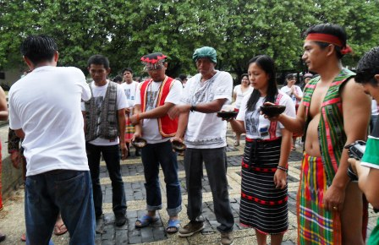
As part of the celebration of the World’s Indigenous People’s Day in the Philippines today, the Cordillera Peoples Alliance together with indigenous people’s organizations from different regions in the country launched partnership with the European Union in a sunrise ritual Panawagtawag at 5:30 AM today at the Bantayog ng mga Bayani, Quezon City. Representatives from the European Un ion office in Manila participated in the said ritual.

“Panawagtawag expresses the unity of indigenous peoples in the Philippines for the defense of their ancestral land, culture and self determination. In this ritual, we affirm our commitment in the struggle for the recognition of our rights as indigenous people as we hope for the new government’s regard for these rights,” CPA Chairperson Win del Bolinget said. IP leaders from the Cordillera garbed in indigenous attires joined the ritual and led the pattong for the unity dance.
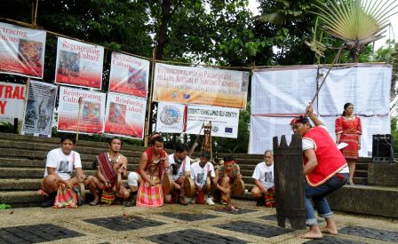
Groups of Lumads from Mindanao performed the said ritual which began with a call to gather followed by an offering of metals and chickens by indigenous leaders and the sharing of indigenous wine basi from the Cordillera. According to Dulphing Ogan of Kusog Katawhang Lumad sa Mindanao (KALUMARAN), “Metals symbolize strength among indigenous peoples, the chickens to ward off evil. The sunrise symbolizes new beginning. With the new president, we expect change.”

EU has recently forged partnership through projects with the Cordillera Indigenous Peoples Legal Center (DINTEG) and KALUMARAN. “We are grateful for the opportunity of a partnership with the European Union and we are confident that this will help us indigenous peoples especially in relation to the assertion of our cultural identity and in strengthening our capacity in advancing our rights as indigenous peoples,” added Bolinget.# CPA Public Information Commission

